Hamilton Workingmen’s Club

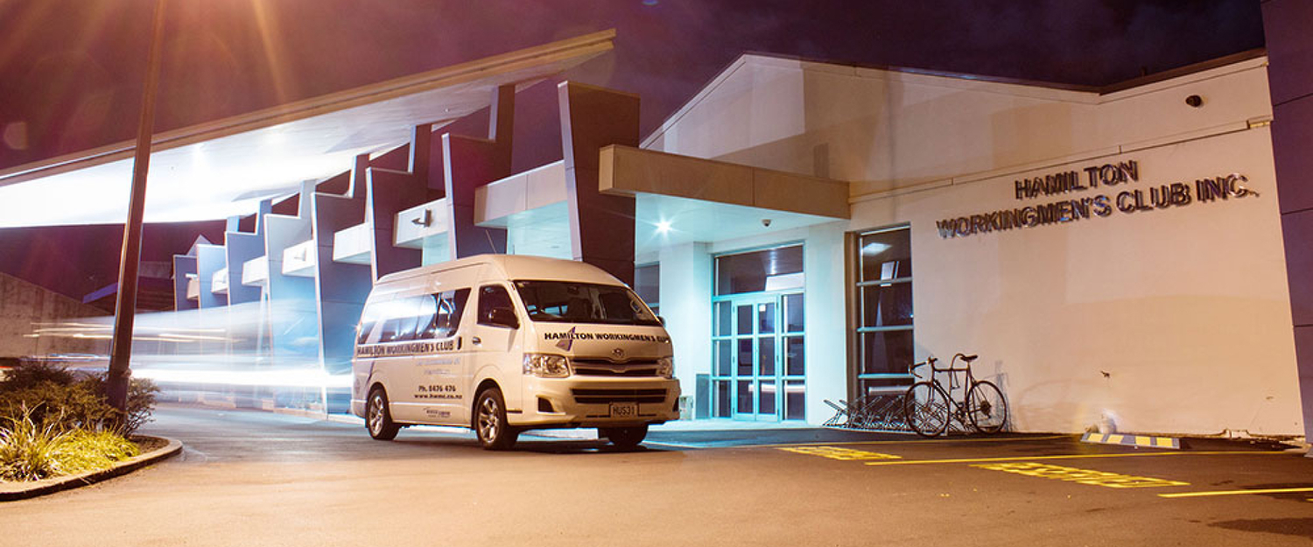

Function & Menu Information

May 2024

Centrally located to provide the perfect space for your next function or event

**Hamilton Workingmen’s Club**

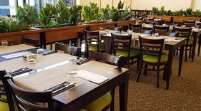

Our aim is to provide our 7000+ members with modern, clean facilities while offering activities and hospitality where they can meet and enjoy one another's company.

Our highly trained and long-standing personnel take pride in our club and ensure that you receive quality service in safe surroundings with ample free onsite parking.

We have 3 function venues, in our Main Club we have our Board Room located on our 1st Floor and on the ground floor we have The Conservatory.

Situated across from the Main Club we have The Pavilion with panoramic views of our 2 bowling greens.

Working alongside your organisation to ensure seamless service and an efficient, productive event or family function our dedicated conference team is on hand to assist. We create bespoke packages which can readily accommodate, lunch and evening meetings. Our buffet-style or tailored menus can cater to your guest’s dietary requirements.

Our venues can be adapted to suit most occasions and have Wi-Fi access, White Boards, Projector Screens, Microphones, Lectern, Television, and Bluetooth capacity in The Pavilion. Most requests can be accommodated but may require an external provider at an extra charge.

**The Pavilion**

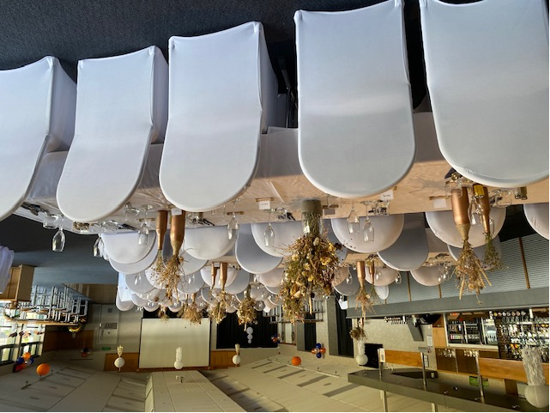

A light-filled and luminous room situated across from the Main Club, The Pavilion has its own separate entrance with an outside seated area that overlooks our bowling greens. The Pavilion can perfectly accommodate small business groups, morning & afternoon-teas, lunches, canapés and sit-down dinners for 150 people when utilising the dance floor area.

The Pavilion has the ability to Bluetooth from your own device.

This function area offers an ideal spot from which to host your next medium-to-large gathering as it has its own dance floor and bar area. The Pavilion is the perfect venue to hire for your next Hamilton Function.

The Pavilion is available to hire to Club Members and Non- Members as well as to host Corporate events – please ask and we can send you floor plans of our most popular set-ups

A Special Liquor Licence will be required at an additional cost for Non-Members

(This will need to be lodged a minimum of 20 working days before function and paid upon conformation of the function or event).

**The Pavilion Room hire – ($250.00 deposit to be paid non refundable)**

Non Members Daily hire $500 incl G.S.T

Daily hire with Bar Facilities $500 plus Liquor Licence incl G.S.T

(Special Licence will need to be applied for at an extra cost)

Club Members Daily hire $350 incl G.S.T

Corporate Hire Price available upon request and function details

**Conservatory**

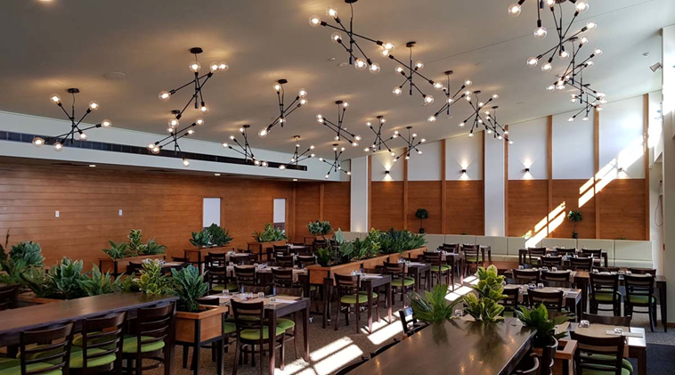

Our Conservatory is situated on the ground floor within the Main Club and is available to

Club Members only.

This is our premium function area and has a spacious deck with an outside seating area. This room offers guests the flexibility to enjoy a larger-scale conference or

a function in comfort - offering something a little different.

Suitable for groups of up to 100 this venue is considered one of the top venues in Hamilton.

**The Conservatory hire**

Club Members Daily hire $250 incl G.S.T (non refundable)

Corporate Hire Price available upon request and function details

**Boardroom**

An ideal match for your next business meeting or executive planning session, the Board Room is located on the 1st floor with in the Main Club.

This is the perfect venue for your next Hamilton meeting and

our room hire process is very easy.

This room is ideally suited to hold up to 20 boardroom style

**The Boardroom hire**

Club Members ½ day hire (1 to 4 hours) $150 incl G.S.T

Full day hire (5 plus hours) $200 incl G.S.T

Corporate Hire Price available upon request and function details

**General Information**

All Refreshment & Catering must be supplied by the Hamilton Workingmen’s Club

**Transport**

The Courtesy Van is available for you and your guests for a safe journey home (Within the Hamilton City Council boundaries).

Taxi services & Sober Driver services can be arranged on the night with the bar staff or Reception in the main Club

**Linen Hire** – we can provide our linen for your event

Basic Black tablecloths $12.00 per cloth

Basic White table cloths $12.00 per cloth

These need to be ordered and paid minimum 1 week prior to function.

Black chair covers – max 90 $2.00 Laundry fee per chair

**Outdoor Bowls or under New cover with your Event**

We can assist you in organising an event including out-door bowls then utilizing the Pavilion facilities. This will require an additional charge but makes for an enjoyable team bonding experience. Please ask our Team for details.

**Cancellations and Amendments**

All catering numbers must be received 4 days prior to your function so we can ensure everything is planned in advance to your event or function.

Cancelation to your event or function One week prior – No charge

1 – 2 days’ notice – 50% of hire fee will be charged

On the Day – Full hire fee will be charged

 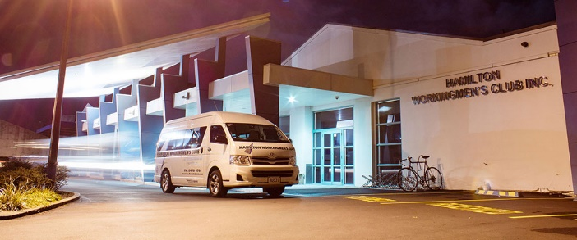

**Finger Food Options**

***OPTION 1***

|  |  |
| --- | --- |
| Club Sandwiches (GF) (2pp) | Assorted Savouries (GF) (2pp) |
| Crumbed Fish Bites | Mini Spring Rolls (V) (2pp) |
| Mini Samosas (V) (2pp) | Mini Corn Pattie (GF) |
| Sweet Corn Nuggets (V)(2pp) | Chicken Nuggets |
| Flame-grilled Meatballs | Battered Onion Rings (V) |

***OPTION 2***

|  |  |
| --- | --- |
| Pizza Bites  Mac & Cheese Bites | Jalapeno Bites  Cajun Chicken Wing Dings |
| Mini Hotdogs | Pork Wontons |
| Broccoli and Cheese Bites (V) | Prawn Twisters |
| Carrot Cake | Banana Cake |
| Chocolate Brownie (GF) | Fresh Fruit Platter (GF) |

***COSTS***

Minimum of 10 people

|  |  |
| --- | --- |
| $16.00 per person | 5 of Option 1 |
|  | 1 of Option 2 |
|  |  |
| $18.00 per person | 4 of Option 1 |
|  | 4 of Option 2 |
|  |  |
| $20.00 per person | 5 of Option 1 |
|  | 5 of Option 2 |
|  |  |

**Meal Options**

***OPTION 1***

|  |  |
| --- | --- |
| Honey Glazed Ham | Roast Beef |
| Roast Pork | Roast Lamb |

***OPTION 2***

|  |  |
| --- | --- |
| Chicken with a Mushroom, Bacon & Red Wine Sauce | |
| Butter Chicken with Rice | |
| Rosemary and Garlic Lamb Chops | Sesame Chicken Nibbles |
| Mac & Cheese Pasta | Beef Ragout |
| Beef Stroganoff and Rice | Thai Green Curry and Rice |
| Sweet and Sour Pork and Rice | |

***OPTION 3***

|  |  |
| --- | --- |
| Roast Potatoes | Minted Potatoes |
| Garlic and Herb Potatoes | Roast Pumpkin |
| Roast Kumara | Cauliflower Mornay |
| Roast Carrots | Honey Glazed Baby Carrot |
| Peas and/or Corn | Tossed Salad |
| Potato Salad | Coleslaw |
| Pasta and Salami Salad | Baby Beetroot Salad |
| Tomato, Red Onion & Olive Salad | Assorted Bread Basket |

***OPTION 4***

|  |  |
| --- | --- |
| Peach and Apple Crumble with Custard | Sticky Date Pudding in Caramel Sauce |
| Apple and Mixed Berry Pie with Custard | Bread and Butter Pudding |

***OPTION 5***

|  |  |
| --- | --- |
| Chocolate Mousse | Fresh Fruit Salad |
| Pavlova | Chocolate Cream Puffs |
| Mixed Berry Cheesecake | Brandy Snaps |
| Chantilly Cream | |

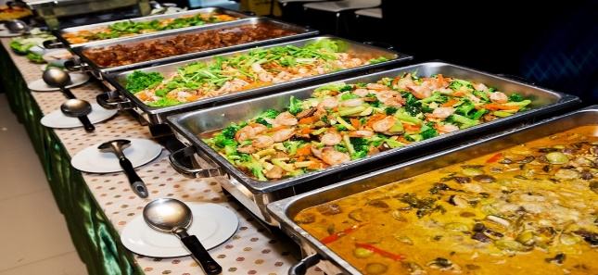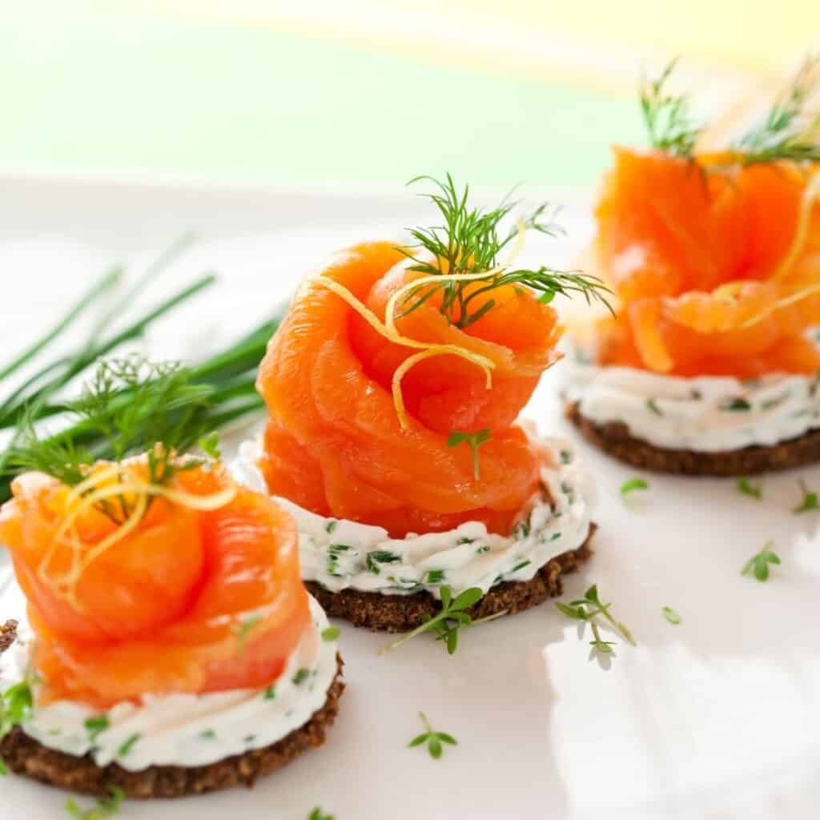**Meal Options**

Minimum 30 people

|  |  |
| --- | --- |
| $45.00 per person | 1 of Option 1 |
|  | 1 of Option 2 |
|  | 5 of Option 3 |
|  | 1 of Option 4 |
|  | 2 of Option 5 |
|  |  |
| $49.00 per person | 2 of Option 1 |
|  | 1 of Option 2 |
|  | 8 of Option 3 |
|  | 1 of Option 4 |
|  | 3 of Option 5 |
|  |  |
| Extras Dishes per person  Option 1 $ 5.00  Option 2 $ 4.00  Option 3 $ 2.50  Option 4 $ 3.00  Option 5 $ 2.50 | |
|  | |
|  | |
|  | |
|  | |

**Wine List**

HOUSE POUR Glass Bottle

KOPIKO BAY CHARDONNAY 8.50 34.00

*Soft ripe pineapple and apricot aromas combined with elegant length and subtle oak nuances*

KOPIKO BAY SAUVIGNON BLANC 8.50 34.00

*Bright ripe gooseberry aromatics with guava and ripe tropical melon flavours*

KOPIKO BAY PINOT GRIS 8.50 34.00

*Aromas of white pear and peach with a spiciness that flows through onto the sublimely balanced palate*

KOPIKO BAY MERLOT 8.50 34.00

*A combination of soft plum and dark berry flavours with hints of peppery spice and lingering mocha*

KOPIKO BAY PINOT NOIR 8.50 34.00

*Aromas of cherry and spice, bright and delicate with superb bright raspberry / strawberry flavours*

SAUVIGNON BLANC

OYSTER BAY SAUVIGNON BLANC 9.50 36.00

*A concentration of tropical and gooseberry flavours*

STONELEIGH SAUVIGNON BLANC 9.50 36.00

*Renowned for its ripe tropical fruit flavours*

VILLA MARIA SAUVIGNON BLANC 9.00 36.00

*Gooseberry, passionfruit, fresh citrus & herbaceous aromas*

WITHER HILLS SAUVIGNON BLANC 9.50 38.00

*Remarkable fruit intensity and style*

AROMATICS

OYSTER BAY PINOT GRIS 9.50 34.00

*Notes of pears, apples, stonefruit, and sweet spices*

STONELEIGH PINOT GRIS 9.50 36.00

*Tropical fruit, fresh pear & Honeysuckle with melon highlights*

VILLA MARIA PINOT GRIS 9.00 34.00

*Crisp, light, Mouth–filling, off-dry Pinot Gris wine that leans towards the sweeter end of the spectrum*

WITHER HILLS PINOT GRIS 9.50 38.00

*Fleshy white peach, quince, grapefruit, and subtle spices*

CHARDONNAY Glass Bottle

OYSTER BAY CHARDONNAY 9.50 36.00

*Concentrated flavours of ripe citrus and stone fruit*

STONELEOGH CHARDONNAY 9.50 36.00

*Nectarine, peach & cream aromas coupled with toasty oak notes*

VILLA MARIA CHARDONNAY 9.00 36.00

*Ripe stone fruit woth complex taste and vanilla flavours*

SPARKLING

LINDAUER – BRUT, FRAISE, SAUVIGNON BLANC, PINOT GRIS 9.80 30.00

LIGHT WINES

BRANCOTT FLIGHT SAUVIGNON BLANC 9.00 35.00

BRANCOTT FLIGHT PINOT GRIS 9.00 35.00

REDS

OYSTER BAY MERLOT 9.50 36.00

*Flavours of juicy black plum and sweet berry fruits, plus spice and subtle oak*

OYSTER BAY PINOT NOIR 10.50 38.00

*Fragrant, soft, and flavourful with aromas of ripe cherry, plums, and gentle tannins to provide*

*structure and length*

STONELEIGH PINOT NOIR 9.50 35.00

*Fruit harvested at peak intensity Bright, rich, red berry fruit characters*

VILLA MARIA PRIVATE BIN MERLOT 9.00 36.00

*Full bodied yet soft and fleshy, characters of dark cherries and plum fruit*

VILLA MARIA PRIVATE BIN PINOT NOIR 9.00 42.00

*A rich array of fruit with subtle oak and earthy aromas*

WITHER HILLS PINOT NOIR 10.50 42.00

*Morello cherry, wild berry, and subtle French oak spice, Delivers a youthful evocative Marlborough Pinot Noir*

WYNDHAM BIN 555 SHIRAZ 9.00 35.00

*Rich plum, blackberry and spicy fruit aromas complexed by subtle vanilla oak*

**Bar Price List**

Tap Beers – Full strength 500ml $8.50

Mid strength 500ml $7.50

House Wine $8.50 per glass

House Spirits Single nip $3.50

Premium Spirits & Liqueurs $4.00 - $5.50 per nip

(Mixer prices dependent on glass size)

RTDs $8.50 - $10.00

Bottled Beers $8.00 - $11.00

Cider Bottle $8.50 - $15.00

Fresh Juice 500ml $4.40 per glass

Soft Drinks 500ml $4.00 per glass

Quotes can be arranged if required

Our Functions Team can answer any questions you may have regarding anything

contained in this booklet.

Please contact:

Angela Donaldson - Executive Chef & Function Manager

Telephone: (07) 8476 476 – Mobile: 027 299 1094

Email – [kitchen@hwmc.co.nz](mailto:kitchen@hwmc.co.nz)

Ken Marcum Club Manager

Telephone: (07) 8476476

Email – kenm@hwmc.co.nz

**HOST RESPONSIBILITY POLICY**

The management & staff of theHAMILTON WORKINGMEN’S CLUBbelieve we have a responsibility to provide an environment that is not only comfortable & welcoming but also an environment where alcohol is served responsibly. Because of this the following Host Responsibility Policies have been implemented

We provide and actively promote a range of non-alcoholic drinksincl. low alcohol beer, fruit juice, soft drinks, tea & coffee. Water is available free of charge at all times**.** Signage and menus indicating this will be visible at all times.

Outside areas will be deemed as supervised areasat all times that alcohol is being consumed there. Management reserves the right to refuse service of alcohol to outside patrons.

**If** there is any doubt as to someone’s age, identification will be checked. Acceptable forms of I.D. are – HANZ 18+ card, Photo Driver’s License, Approved Photo I.D., Passport. - Underage guests will be asked to leave the premise.

**Patrons who are visibly intoxicated will not be served alcohol**. Alternatives will be offered including food, water, or tea & coffee. Staff are trained to recognise signs of intoxication and practical interventions. Staff are instructed to not serve alcohol to patrons they suspect are becoming intoxicated either directly or indirectly through friends.

Patterns of drinking will be closely monitored. Stockpiling, Boat races, drinking challenges or overzealous cocktails will not be allowed as they invariably lead to intoxication.

We promote the use of alternative transport. The Club operates a fully licensed Courtesy Bus service. Dial a driver services are available. Phones are available free of charge for arranging alternative transport. Staff may request the surrender of car keys should this be deemed necessary.

We expect all Patrons to conduct themselves in an orderly and proper manner at all times**.** If patrons spoken to do not adhere to our requests then we will ask and insist that they leave the premise immediately. Failure to comply may jeopardize future entry.

We are committed to ensuring that ALL staff receive thorough, up to date training, and resource materials relating to all aspects of their work including the Sale and Supply of Alcohol Act 2012 and Host Responsibility.

OUR AIM IS TO PROVIDE A SAFE & ENJOYABLE ENVIRONMENT

**CONDITIONS OF PAVILION HIRE FOR EVENTS**

Upon conformation for a Pavilion booking a deposit of $250.00 will be required to secure the date of the function or event

Bond for Damage $500.00 – If no damage to venue the $500.00 will be returned. But if damage is done and exceeds the $500.00 then the Hirer will incur additional repair costs.

If a function or event has more than 100 people attending where the Management Team thinks it is required, security will be essential, a charge for Security will be added to the cost of the Function or Event

Special License Fee for NON-Members requiring the Pavilion Bar will need to be applied for and must be lodged within 20 working days prior to the function with the Hamilton City Council Liquor Licensing Board. The cost of this will be required before the application process and will be charged at the current Hamilton City Council Fee – Please ask the team for more details on this.

* Entry into a 21st Birthday will be presentation of invite to the Function. The Function is not to be published on Social Media. A Parent must also be involved in the organising of this event and must be present during the entire function
* No Yardie or 21 shots to be consumed on premise.
* No Alcohol to be bought onto premise, if it is then it will be confiscated. If it is a wrapped gift it will be left with the bar staff until the end of the function.
* Food must be supplied on the night and arranged through HWMC. Menu’s to be supplied by the Catering / Function Manager at HWMC.
* Bar – Cash, a tab or subsidized – to be discussed at the time of the booking. All beverages must be purchased through HWMC.
* Music – Hirer is responsible for their own organizing.
* Fences will be erected and NO ONE is allowed on the bowling greens.
* No Drugs to be consumed at the function. If anyone is found to be doing this they will be asked to leave.
* No Drinking in cars or the carpark.
* Hours of Hire – Bar will close at 11.30 pm and all attendees to the event or function must be off the premises by 12 midnight.
* Set up – to be discussed with the Function Team.

Hirer will need to sign the hire agreement and payment made at the time of booking.

**PAVILION HIRE AGREEMENT / PERSONAL GUARANTEE**

I hereby agree to the terms and conditions of hiring The Pavilion at the Hamilton Workingmen’s Club, 45 Commerce Street Frankton, Hamilton. I have read and understand the Conditions of Pavilion Hire for Events that was discussed with me and is within the Functions and Menu Information dated September 2022. Any additional costs will be discussed with the Function Team and the person hiring the Venue.

Full Name:__________________________________________________

Address: ___________________________________________________

Phone number:_________________________

Member number: _______________________

Date Function to be held:__________________________________

Deposit Payment date: _________________

Amount paid:_______________________

Signature:______________________________